**Mockito_Hands_On_Exercises**

## **Exercise 1: Mocking and Stubbing with Mockito**

### **🎯 Scenario:**

You want to test a service (MyService) that depends on an external API (ExternalApi) by using **Mockito** to:

* Mock the API,
* Stub the method getData(),
* Verify the result in the service.

### **Step 1: Add Mockito + JUnit 5 to pom.xml**

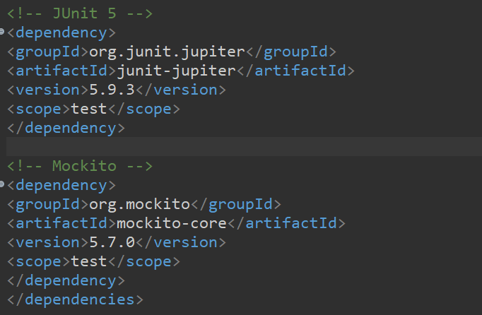

### **Step 2: Create the Interface (External API)**

📁 src/main/java/com/example/ExternalApi.java

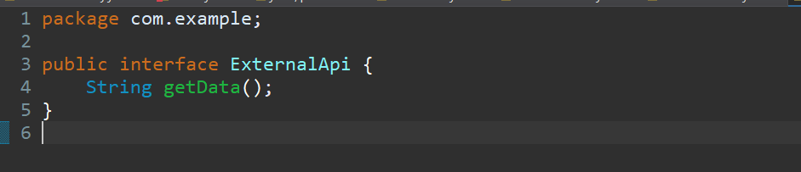

### **Step 3: Create the Service That Uses the API**

📁 src/main/java/com/example/MyService.java

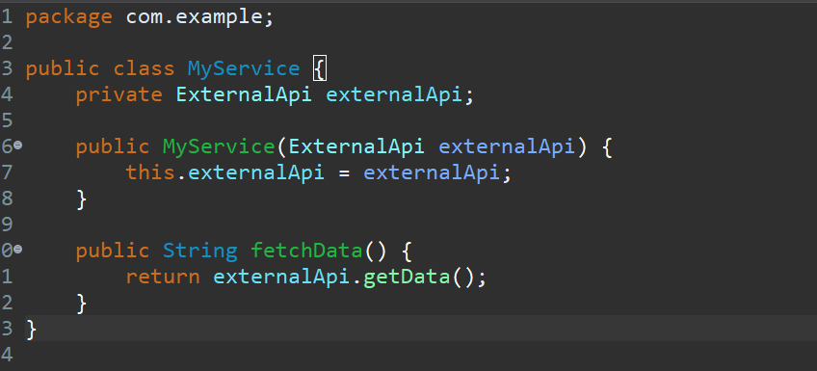

**Step 4: Create the Test Using Mockito**

📁 src/test/java/com/example/MyServiceTest.java

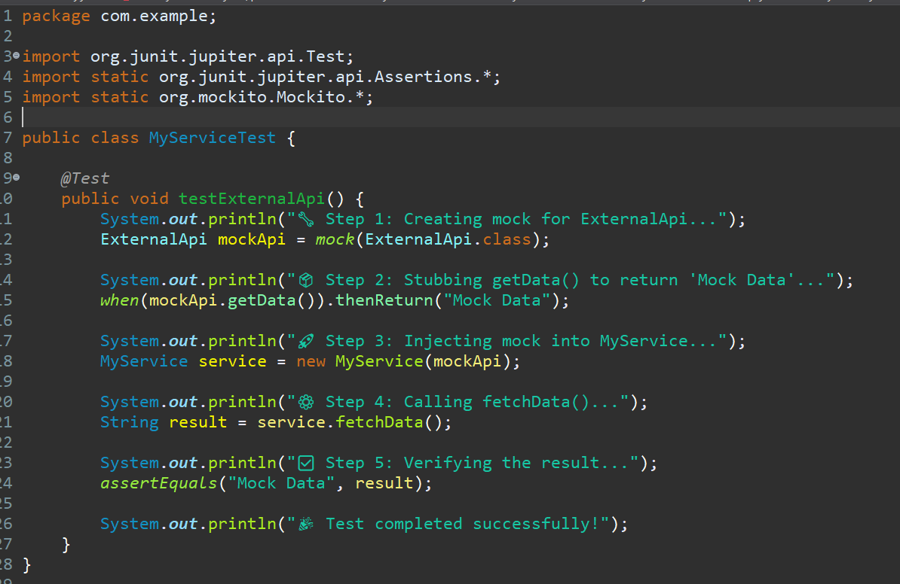

## **✅ Expected Output**

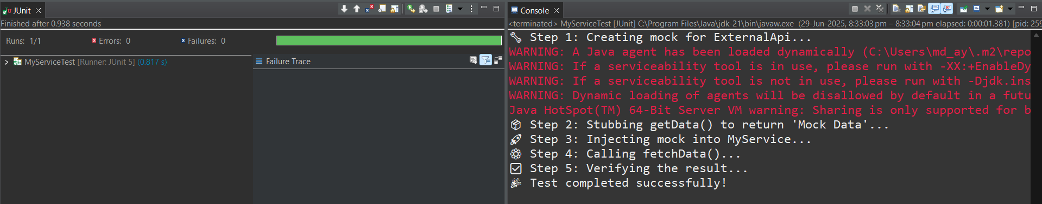

## **✅ Exercise 2: Verifying Interactions**

### **🎯 Scenario:**

📁 ExternalApi1.java

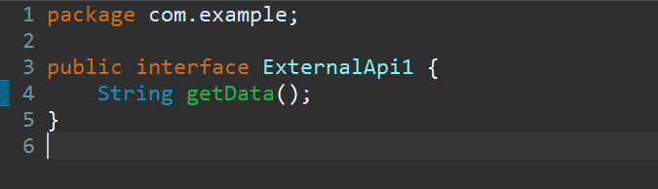

📁 MyService.java

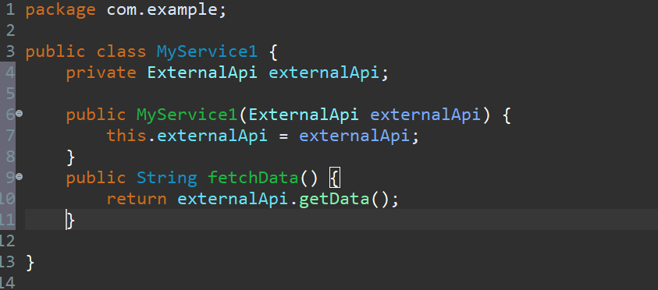

### **🧪 Updated Test Code with Verification + SOPs**

📁 MyServiceTest.java

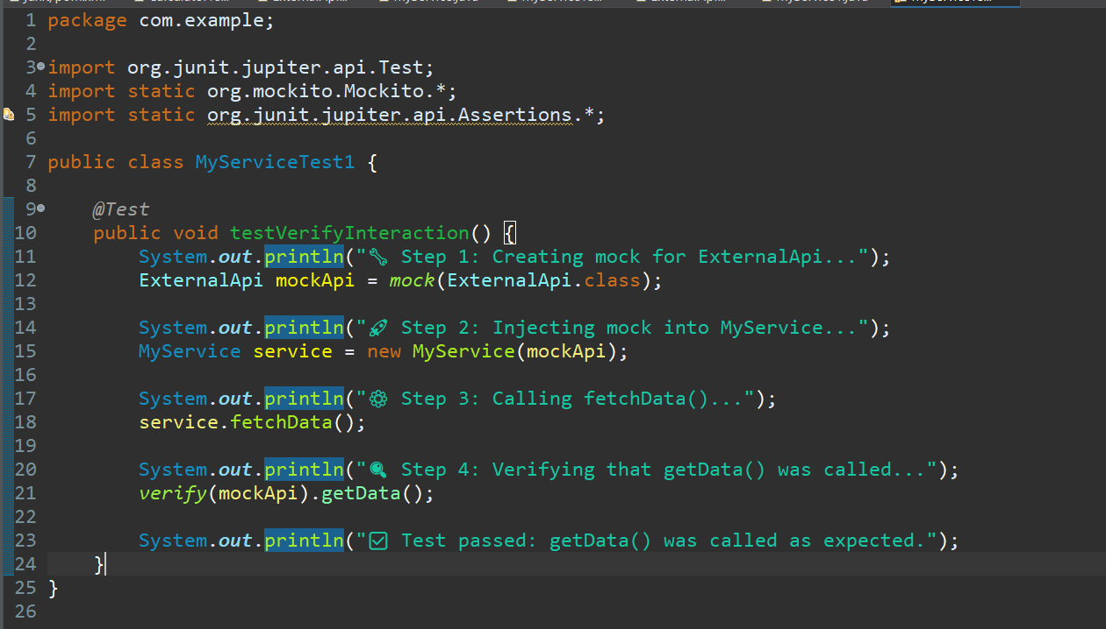

## **✅ Expected Output**

